1. Trip to Nainital
Dates: 30 October – 02 November 2025
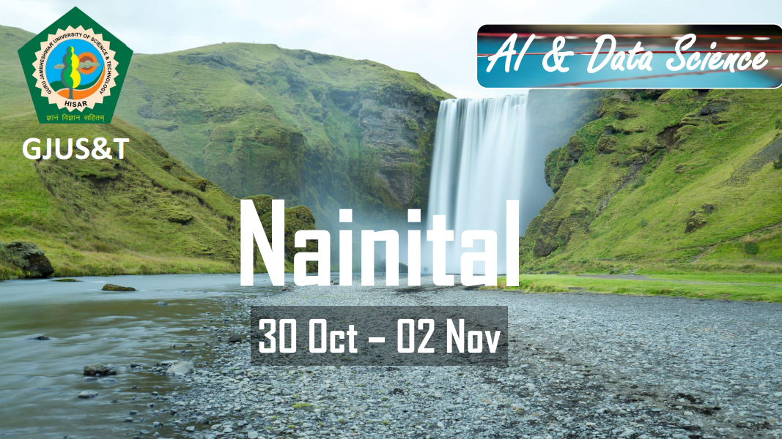

2. World Statistics Day 2025 Celebration
Date: 20 October 2025
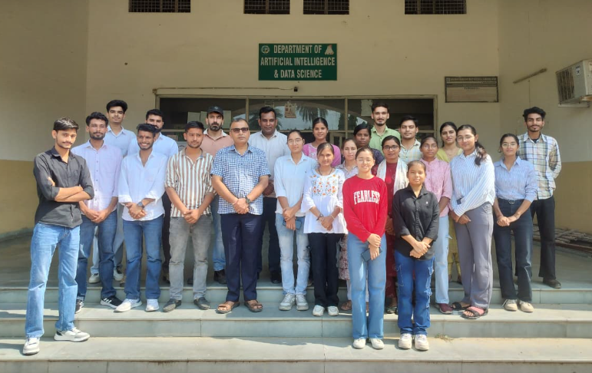

3. Industrial Interaction and Placement Invitation Session
Date: 5 October 2025
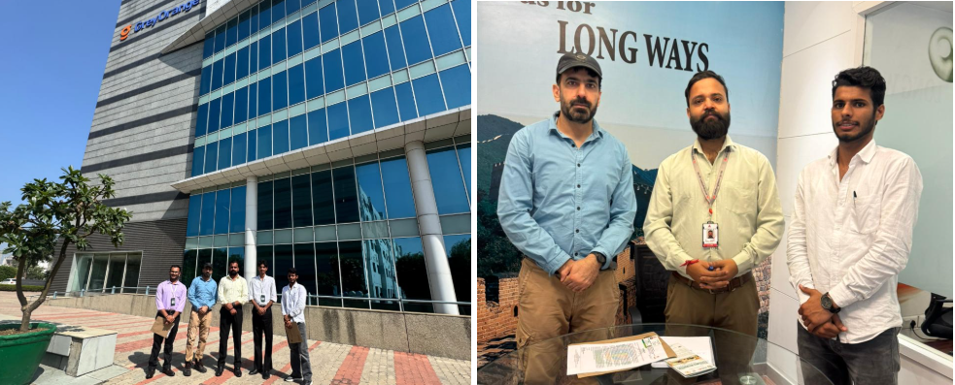

4. Welcome Fresher Party for M.Sc. Students
Date: 27 September 2025
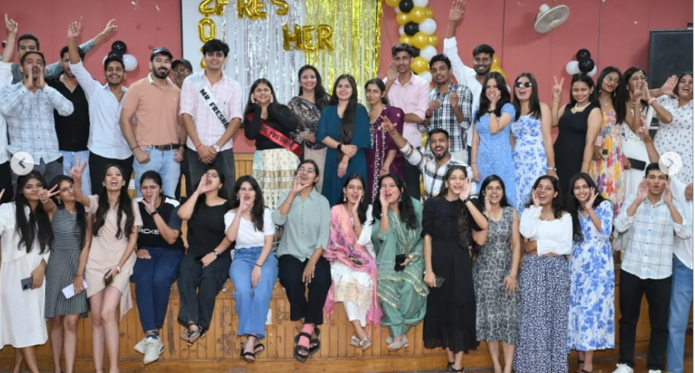

5. Welcome Fresher Party for B.Sc. Students
Date: 14 September 2025
6. Teacher's Day Celebration
Date: 5 September 2025
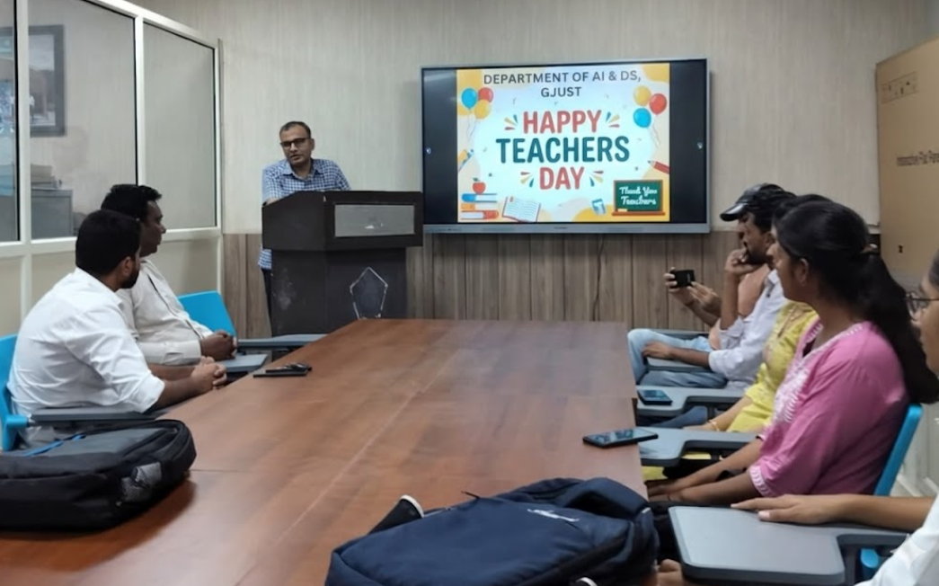

7. Workshop on Data Analytics with Python
Dates: 20–24 March 2025
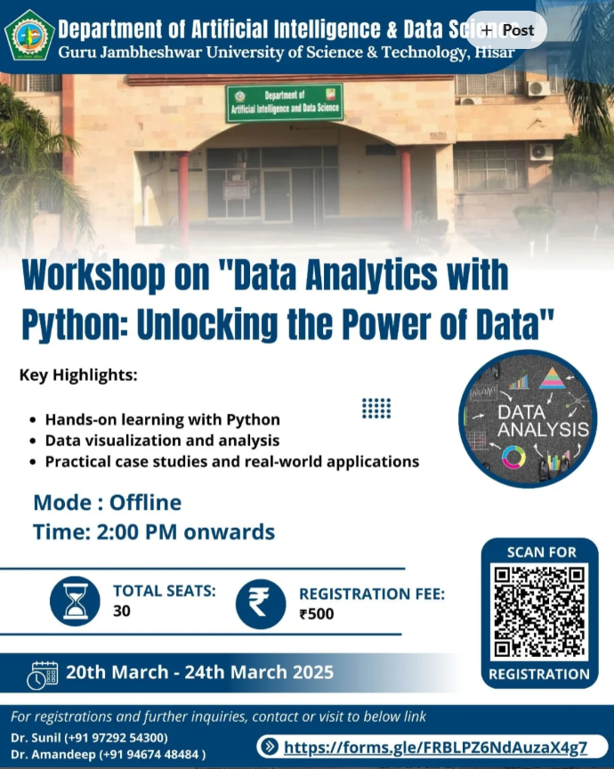

8. Faculty Development Programme on Artificial Intelligence and Data Analytics (AIDA-2024)
Date: March 2024
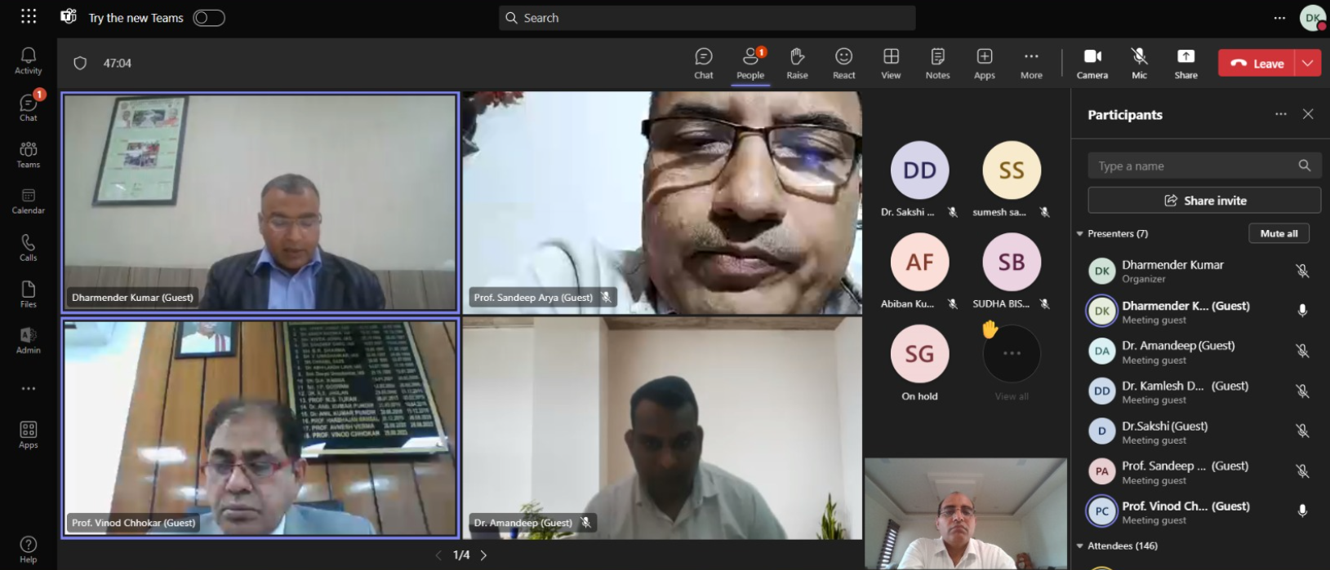

9. Two-Day Workshop on Excel
Dates: 28–29 September 2023
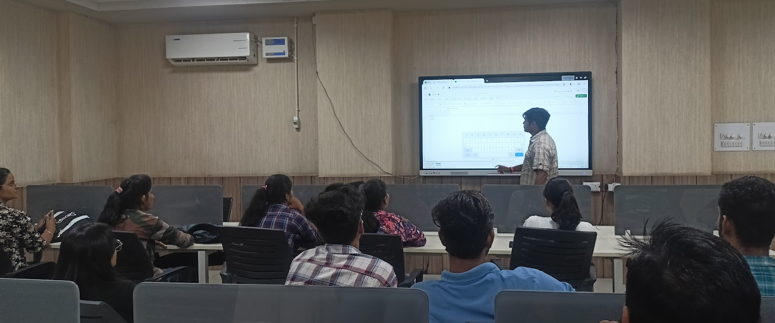

10. Industrial Interaction Session
Dates: 29 September 2023

