
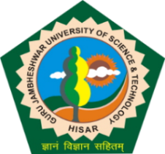
Guru Jambheshwar University of Science and Technology, Hisar
(Established by State Legislature Act 17 of 1995)
(A+ Grade NAAC Accredited)

Dated: 24.12.2025

ADMISSION NOTICE 2025-26

Advance Diploma in Child Guidance and Counseling (A.D.C.G.C.)
(RCI approved programme)

The Online application forms are invited w.e.f. 25.12.2025 for admission to Advance Diploma in Child Guidance and Counseling (A.D.C.G.C.) programme for the academic session 2025-26. The last date for submission of online application form is 01.01.2026 (upto 5.00 p.m.). The detailed Admission Notice having information relating to key-dates, eligibility, number of seats, date of entrance test, counseling schedule and fee structure etc. are available on the university website www.gjust.ac.in
Sd/-
DEAN ACADEMIC AFFAIRS

