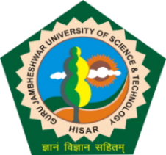**Guru Jambheshwar University of Science and Technology, Hisar**

**(Established by State Legislature Act 17 of 1995)**

**(A+ Grade NAAC Accredited)**

**ADMISION NOTICE 2025-26**

**B.TECH. (WORKING PROFESSIONALS) AND MBA (WORKING PROFESSIONAL) PROGRAMMES**

The Online applications are invited for admission to B.Tech. (Mechanical Engineering), B.Tech. (Computer Science and Engineering), B.Tech. (Electrical Engineering) for Working Professional and MBA (Working Professional) Programmes for the academic session 2025-26 w.e.f. 17.07.2025. The detailed Admission Notice having information relating to admissions, counseling schedule etc. are available on the university website [www.gjust.ac.in](http://www.gjust.ac.in) . The last date for submission of Online application form is 31.07.2025.

REGISTRAR